Contents
Accessing Cayuse 1
RM.EDU accounts 1
Guest Accounts 1
Accessing the Human Ethics Dashboard 1
Researcher Dashboard Overview Video 2
Certifying a Submission 3
Addressing Comments 3
Recertification 4
Viewing Submission Details and History 4
From Study Details 4
From Your Dashboard 5

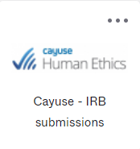
Accessing Cayuse

RM.EDU accounts
Advisors using an rm.edu email should find the Cayuse Chiclet on their Okta dashboard.

Guest Accounts
Advisors using non rm.edu email should save/bookmark https://rm.app.cayuse.com/guest for accessing the submission system.

Accessing the Human Ethics Dashboard
To access the Dashboard, you must first choose Human Ethics from the landing page, using Products in the upper right.

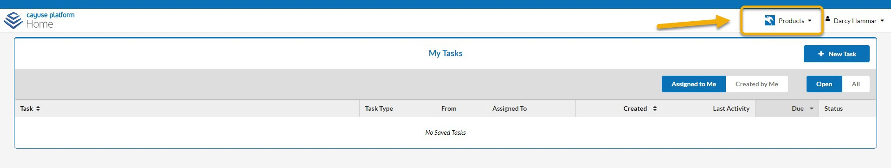

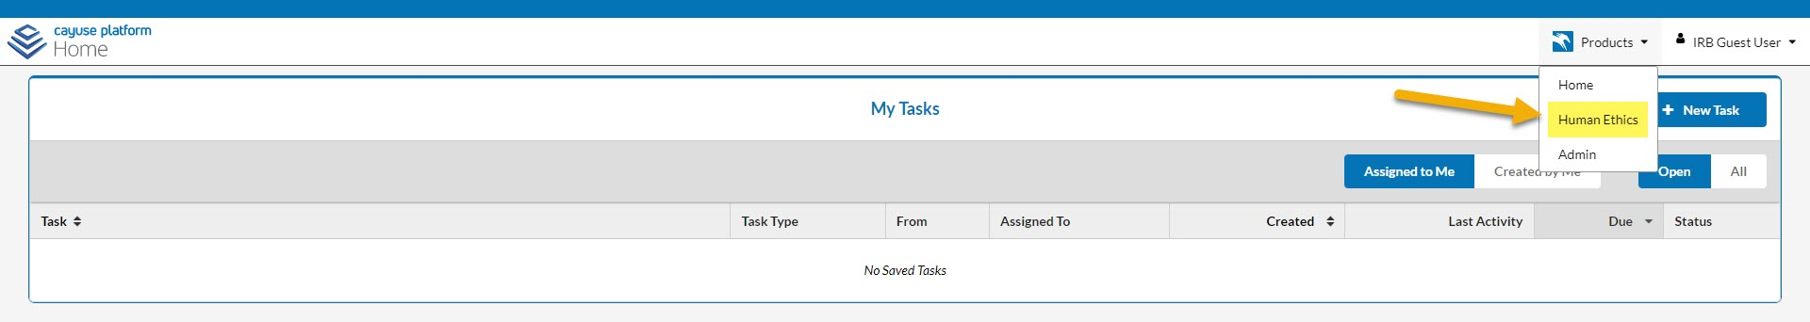

The Dashboard looks like this
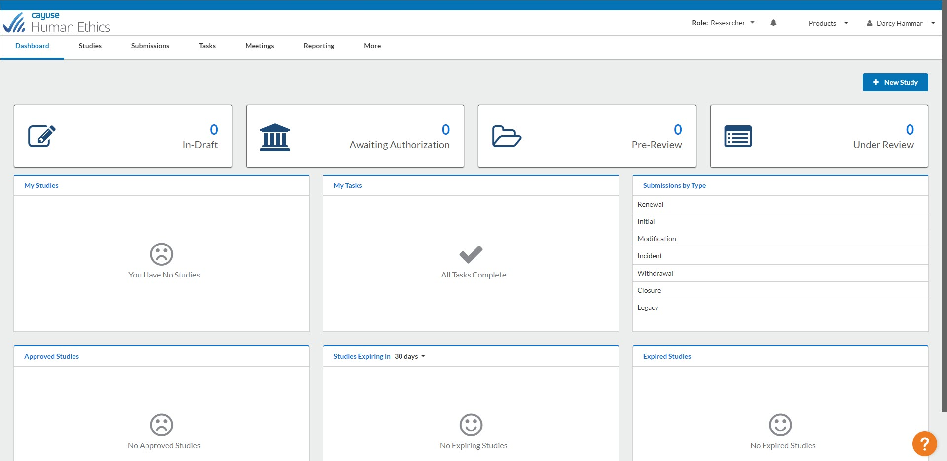

Researcher Dashboard Overview Video

To view a 2-minute video, log in to Cayuse Human Ethics, then select the orange question mark icon in the bottom right corner to open the Resource Center.

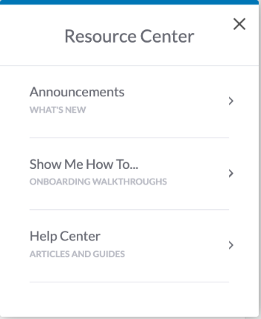
Select Help Center and enter “dashboard” in the search box.
Select Researcher Dashboard Overview Video.

Certifying a Submission
The PI will have marked the submission complete and certified it, routing it to you, the Advisor to review.

Advisors must also certify the submission. You also have the ability to return to the submission to the PI for corrections.

The Advisor certification affirms:
- I confirm that the PI has the proper training, expertise, and resources to conduct this study.
- I understand and accept my responsibilities as the Principal Investigator OR as the Faculty Advisor for this study.
- I confirm that I have no significant financial conflict of interest in this project or have disclosed a conflict per institutional policies and federal requirements.
- I confirm that the information provided in this application is true, complete, and accurate to the best of my knowledge; that any false, fictitious, or fraudulent statements or claims may subject me to criminal, civil, or administrative penalties; and agree to accept responsibility for the oversight and scientific conduct of the project.

It is RMUoHP and the IRB’s expectation that you have reviewed the contents of the application and the attachments before certifying the submission.

Addressing Comments
An Analyst or IRB Member may comment on various questions within the submission forms. The Analyst will return the submission to the investigators for the investigators to address any of the comments.

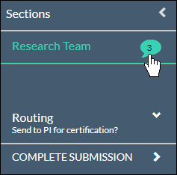
Sections with unresolved comments have a comment bubble icon indicating the total number of unresolved comments in that section. Click on the section to see which questions have a comment attached.

Depending on how far the submission progressed, you may see comments from the Analyst or from IRB member(s) reviewing the submission.

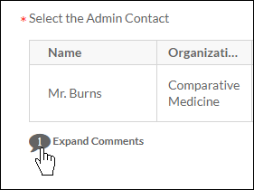
Click on the numbered comment bubble to view the unaddressed comments associated with each question.

Click Reply if you would like to enter a reply and click Save.

Edits should be made directly in the application.

Once you have resolved an issue, change the status drop-down from to .
All comments must be marked as addressed before the submission can be completed.

Recertification
When a submission is returned to the research team, all previous certifications are cleared. Once all comments on the submission have been addressed and the submission has been completed, the PI and advisor will need to re-certify the submission to return it to the Analyst.

Viewing Submission Details and History

From Study Details

From the Study Details page, click on the Submissions tab.

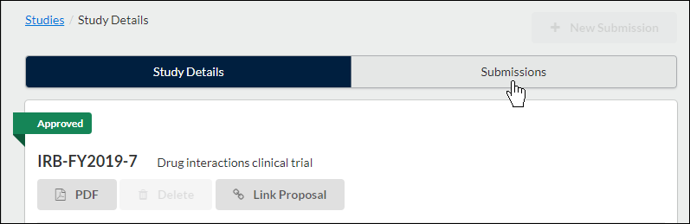
The Submissions tab shows the list of submissions associated with the study, including the submission type, review type and status, decision, and last modified date. Click on the submission you wish to view.

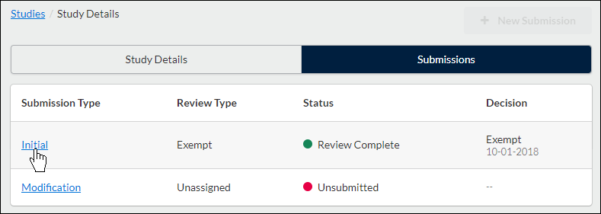
At the bottom of the Submission Details screen, you'll see tabs that vary depending on the submission stage. Tabs may include Approvals, Task History, Letters, Meetings, Decisions, and Linked Proposals.

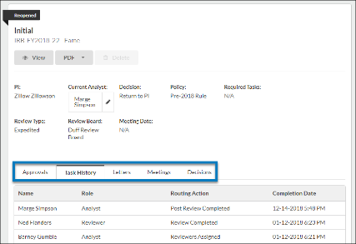
Click on the desired tab to locate the required information.

From Your Dashboard

Click on Submissions in the menu.
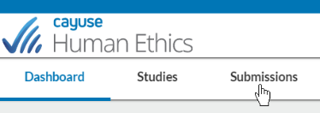
Search for the submission you wish to view, and then click on the submission.

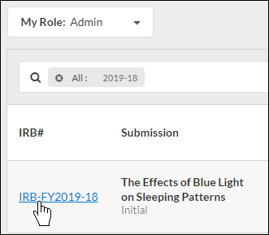
This will bring you to the Submission Details page.

