Approve New Certificate Instructions
Set up time with Cayuse to update the certificates. Once they do that, the new certificates need to be validated by the e-Biz POC in Grants.gov. After logging in to Grants.gov, you (the EBPOC) should see this screen:
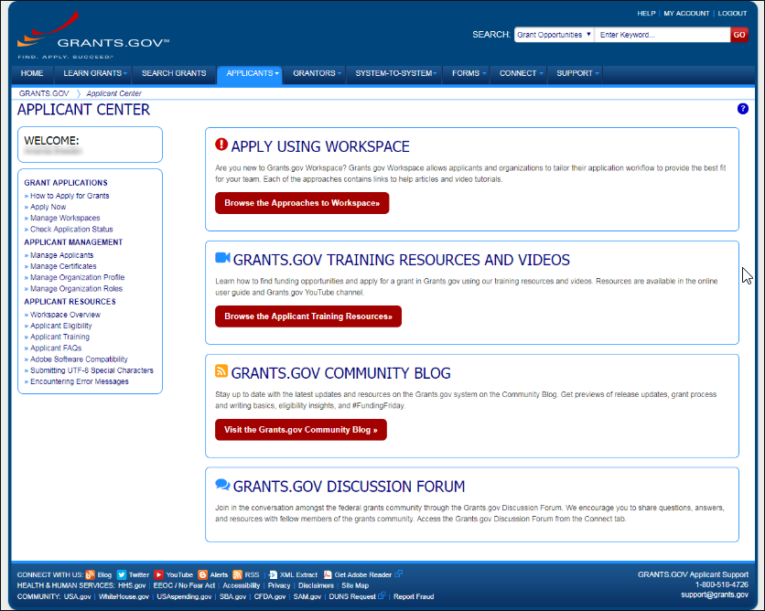​
Click on Manage Certificates:
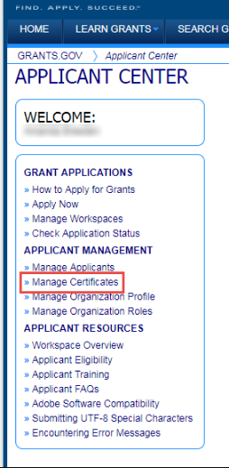​
Find the relevant certificate in your list. It should be the one with an expiration date of next year or look for the latest Expiration Date . Click Manage Roles:
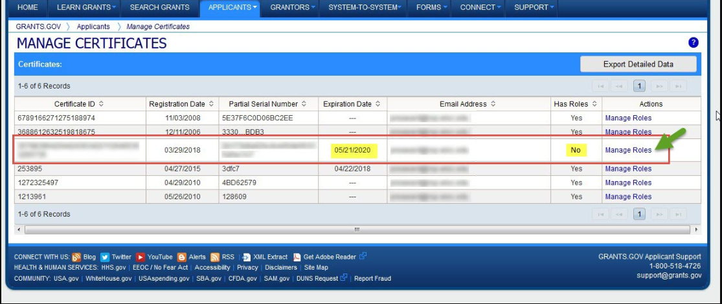​
Select "Standard AOR Certificate" and Click Save:
