Viewing and Downloading

Letters
During the submission process, the IRB office may send a letter to the PI notifying the PI of status changes, approvals, and needed information. Letters are sent via email and are available to download directly from Submission Details in Human Ethics.
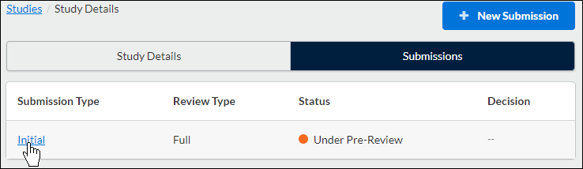

The Letters tab appears for a submission when there is at least one letter associated with that submission. To view a letter, click on the letter tab.
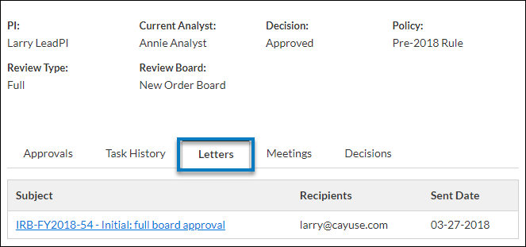

You will be able to view the subject, send date, and recipient(s) for each letter. You can click anywhere on the line to open a PDF of the letter in a new window.
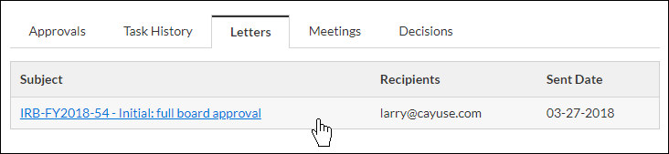

Stamped Documents
To view a stamped document, look under Attachments and for the stamped icon. Download the PDF attachment by clicking on Download next to the document.

