This document is long as each section includes text, images, and gifs taken directly from the Cayuse Support Center.

From the Contents below, Use <CTRL>+mouse click to jump to the appropriate section

Contents
Accessing the Dashboard 2
Researcher Dashboard Overview Video 2
Creating a New Study 3
Creating an Initial Submission 4
Completing Submission Forms 5
Help with Questions 7
Completing a Submission 8
Certification 9
Reopening Your Submission 10
Searching for Studies and Submissions 10
Missing Studies or Submissions 11
Addressing Comments 11
Viewing and Downloading 13
Letters 13
Stamped Documents 14
Save to file 15
Viewing Submission Details and History 16
From Study Details 16
From Your Dashboard 17
Understanding Submission Types 18
Available Submission Types 18
Creating a Modification Submission 19
Creating a Renewal Submission 21
Closing a Study 22
Deleting a Study or Submission 23
Deleting a Study 23
Deleting a Submission 23

Accessing the Dashboard
To access the Dashboard, you must first choose Human Ethics.

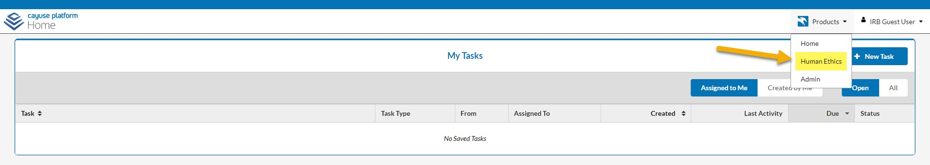

Researcher Dashboard Overview Video
To view a 2-minute video, log in to Cayuse Human Ethics from your Okta dashboard, then select the orange question mark icon in the bottom right corner to open the Resource Center.

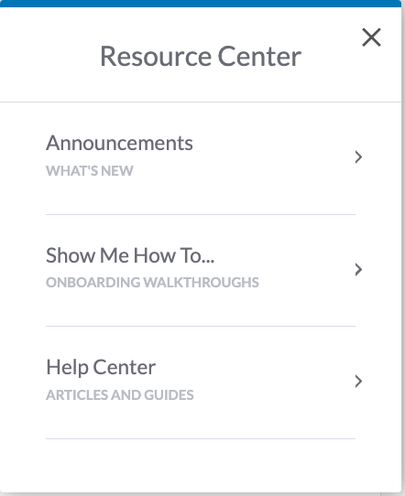
Select Help Center and enter “dashboard” in the search box.
Select Researcher Dashboard Overview Video.

If you select Show me how you will be shown Create a Study and Initial Submission

Creating a New Study

As a Researcher, you can create a new study from your Dashboard or the Studies page within Human Ethics.
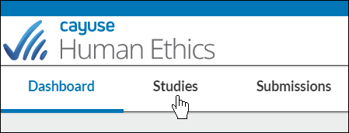

A Study is a container for all of your submissions, actions, and changes on a particular research activity. You must create a study before creating your initial submission.

- Click in the upper right-hand corner of your Dashboard or the Studies page.
- Enter the title of your study. The title can be up to 600 characters long.
- Click to save your study.
After creating your study, you will be taken to the Study Details page. Here, you will see where important study information will populate once you begin your submission.
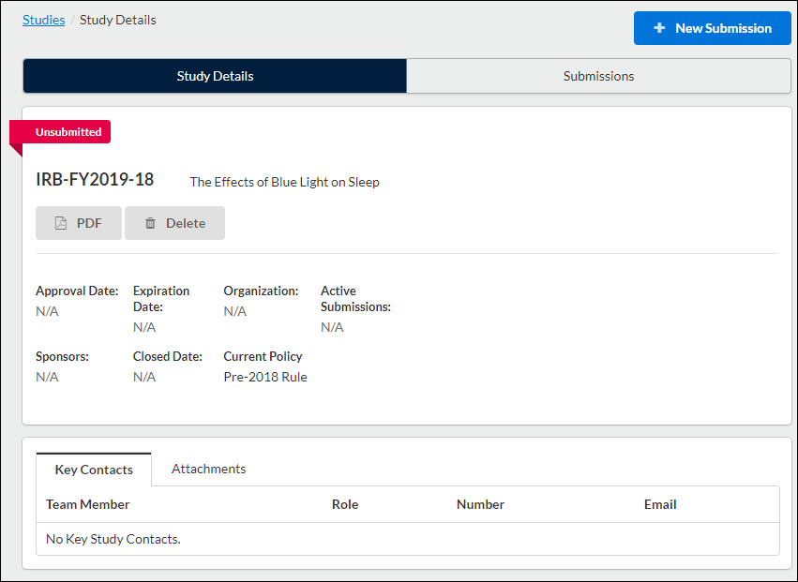

The person who creates the study is added as the primary contact by default. You can change this when editing the submission.
You can rename your study up until the completion of a withdrawal or admin closure submission. From the Study Details screen, hover over the study title and click within the field to edit.

Once you create your study, you can begin your initial submission. Click on New Submission in the upper right-hand corner to start completing your forms.
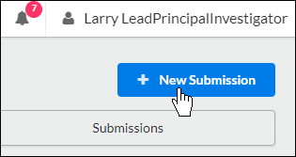

Creating an Initial Submission

After you create a new study, you can begin completing forms for your initial submission by clicking on New Submission, and then clicking Initial from the drop-down menu.
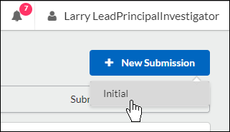

Submission information will populate beneath the Submission Details tab. The person who creates the study is added as the Primary Contact by default, but this can be changed when editing the submission. Make sure to not remove yourself from all roles and Save, or you will not be able to access your submission once you leave.

Click on to begin your submission forms. You will always be able to return to your incomplete submission by clicking this button.

Once on the Initial Submission form, you can return to the Submission Details page by clicking on Study in the upper left-hand corner of the screen.
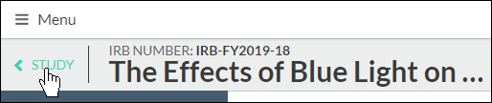

Use the buttons to toggle between sections. You can also click on a section name in the menu at left to jump to that section.

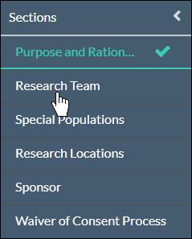

Completing Submission Forms

There are several types of questions on the submission forms:
- Radio Buttons: Select one of the available options.
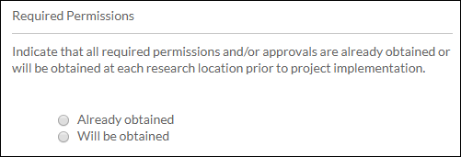

- Check Boxes: Select one or more of the available options.
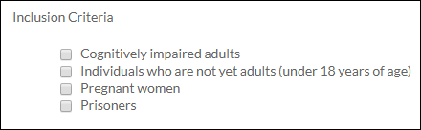

- Date Picker: Click within the field to browse for a date.

- Text Box: Provide a short answer to the stated question (200-character limit). If you need to enter multiple lines of text, the box will expand to fit.

- Text Area: Provide a detailed answer to the stated question. You can use formatting such as bold, italics, underline, strikethrough, bulleted lists, numbered lists, and hyperlinks.
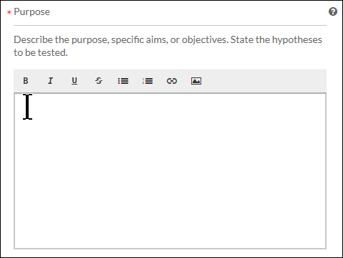
You can also add PNG or JPG images using the image button . Once your image is inserted, you can edit the image by clicking on the image and then clicking Edit.
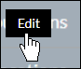

- Person Finders: While every initial submission will require you to add a Primary Contact and Principal Investigator, your institution may have you add other people to different sections within your submission. Click on the finder button to bring up a search dialogue.
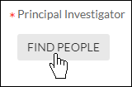
Search for the individual that you wish to add, select them, and click Save.
- Attachments: Upload one or more files to the study by clicking 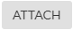. Human Ethics supports the following file types:
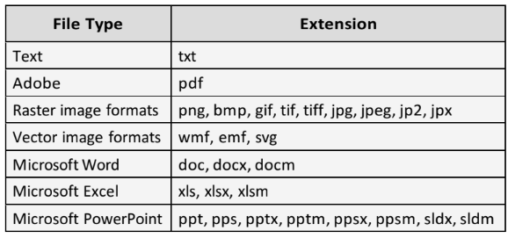
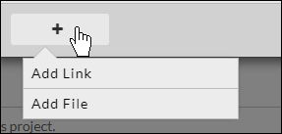
- You can also include hyperlinks as "attachments" by choosing Add Link from the + drop-down menu.
To delete an attachment, click the icon next to the attachment.

Please note: Some questions have next to the question number. This indicates a required question.
Sections with unsaved changes have an asterisk next to the section name.
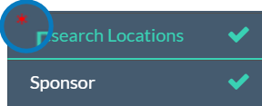
To save your changes, click in the upper right-hand corner.

Help with Questions
If there is help text for a question, you can click on the button to view the additional information for that question.
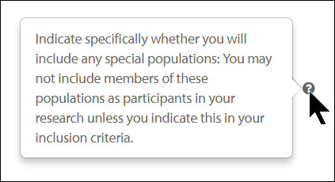

Once there are check marks next to all of your sections, you have completed the submission forms and are ready for routing. Please note: If one of your sections doesn't have a check mark and you aren't sure why, search the section for any required questions you may have missed.

Please note: Human Ethics will warn you with a red lock icon if another user is currently editing a section. You won't be able to edit that section until they're done with their edits.
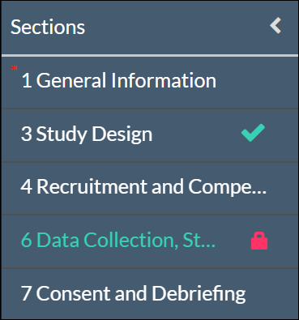

Completing a Submission

The Complete Submission button will only appear when you have check marks next to all of your sections. If one of your sections doesn't have a check mark and you aren't sure why, click on the section to search for any required questions you may have missed.

Once you have filled out every section of your submission and have added all required attachments, a Complete Submission option appears beneath Routing within the menu.
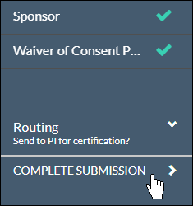

After clicking Complete Submission, you will be prompted to Confirm or Cancel.
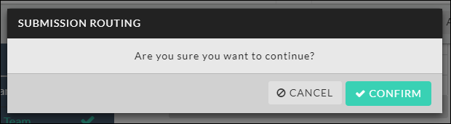

Upon confirmation, you will see the status of your submission change to Awaiting Authorization on the Submission Details page. To certify the project click on the Certify button and confirm your certification.

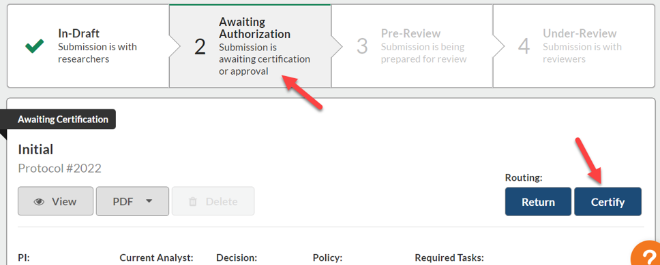

Certification
The system is built with the understanding that the person completing the submission may not be the PI. When it is the PI, the PI also needs to certify their own complete submission. If you are a PI completing your submission, you should certify the submission at this time.

If the Submission is completed by a collaborator, the completed submission is sent to the PI for certification. The PI will receive an email letting them know that the submission needs to be certified. When the PI certifies the submission, they are asserting the submission is complete and accurate and are accepting their PI responsibilities.

If the PI decides that changes need to be made, they can send the submission back. All research team members will receive an email notifying them of the change in status so they can make the necessary edits and complete the submission once more.

Student PIs: Your faculty advisor also certifies the submission. The advisor has the ability to return to the submission to the research team.

Recertification: If the submission does get returned to the research team, all previous certifications are cleared. All individuals who were required to certify the submission in previous rounds of routing must recertify every time the submission is returned before it can move forward.

Reopening Your Submission
To reopen the submission and make edits, click on the button within Submission Details.

Searching for Studies and Submissions

To search for a specific study or submission you have worked on in Human Ethics, click on either the Studies or Submissions tab.
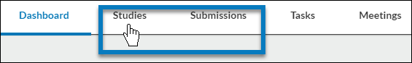

Click into the search box and select a filter from the drop-down list.
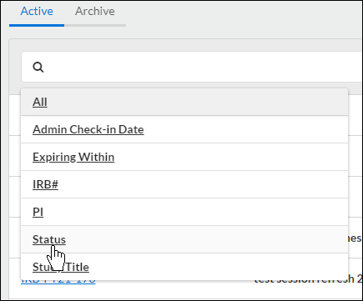

In the filter's gray area, type in your search criteria until you see it in the drop-down menu, then click on the item.
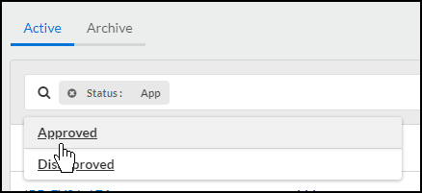
In the results, click on your study or submission to be brought to the Study Details or Submission Details page.

Missing Studies or Submissions
If you can't find a study or submission, it may mean that you've been removed from the research team. The primary contact must re-add you in order for you to regain access. They can do this by creating an Initial or Modification submission.

Addressing Comments

When a submission has been certified by a PI and sent to the Analyst, the Analyst or other individuals reviewing the submission may comment on various questions within the submission forms. The Analyst will return the submission to the investigators, and the investigators will need to address any of the comments.

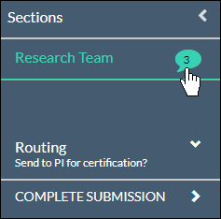
Sections with unresolved comments have a comment bubble icon indicating the total number of unresolved comments in that section. Click on the section to see which questions have a comment attached.

Depending on how far the submission progressed, you may see comments from the Analyst or from the member(s) reviewing the submission.

- Click on the numbered comment bubble to view the unaddressed comments associated with each question.
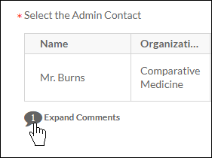

- Click Reply. Enter your reply and click Save.
- Once you have resolved an issue, change the status drop-down from to .
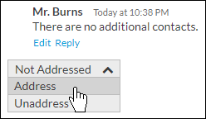

You must mark all comments as addressed before the submission can be completed.

Once all comments on the submission have been addressed and the submission has been completed, the PI will need to re-certify the submission to return it to the Analyst.

Viewing and Downloading

Letters

During the submission process, the IRB office may send a letter to the PI notifying the PI of status changes, approvals, and needed information. Letters are sent via email and are available to download directly from Submission Details in Human Ethics.
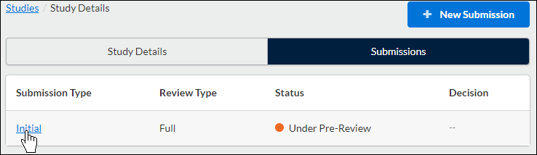

The Letters tab appears for a submission when there is at least one letter associated with that submission. To view a letter, click on the letter tab.
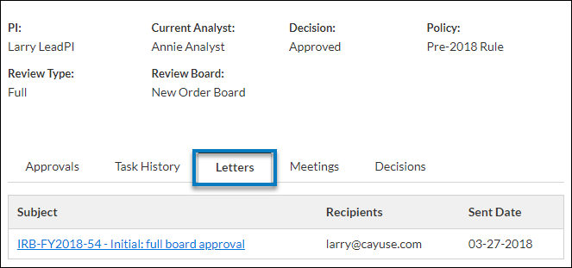

You will be able to view the subject, send date, and recipient(s) for each letter. You can click anywhere on the line to open a PDF of the letter in a new window.
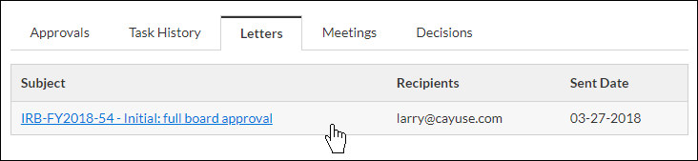

Stamped Documents
To view a stamped document, look under Attachments and for the stamped icon. Download the PDF attachment by clicking on Download next to the document.

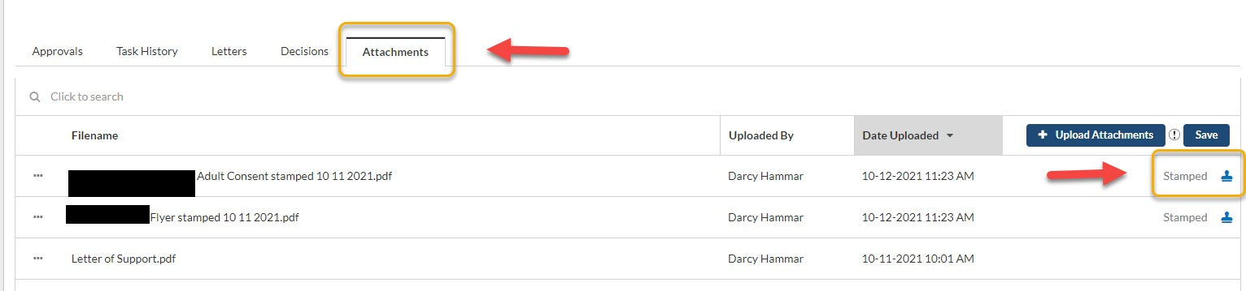

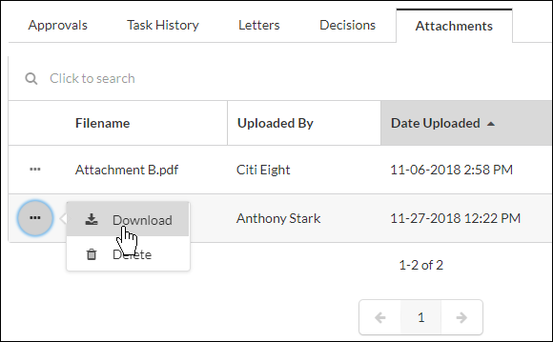

The stamp will always appear on every page of the PDF.

Save to file
  - Chrome: Right-click within the opened PDF and select Save As.
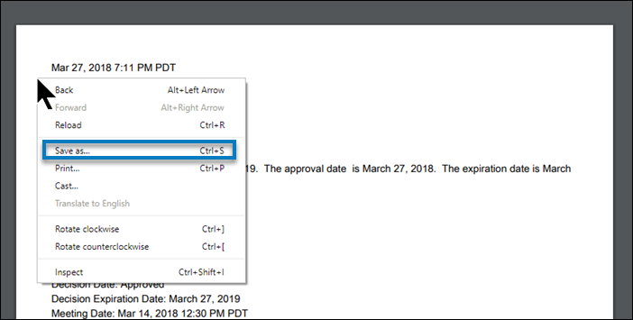

  - Firefox: Right-click within the opened PDF and select Save Page As.
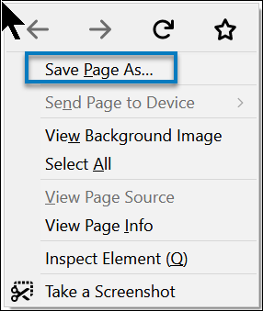
  - Internet Explorer: In the menu bar, click on > File > Save As.
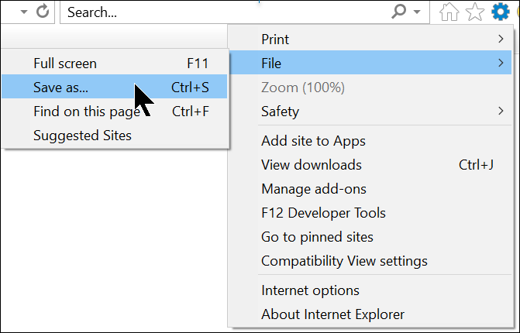

Viewing Submission Details and History

From Study Details

From the Study Details page, click on the Submissions tab.
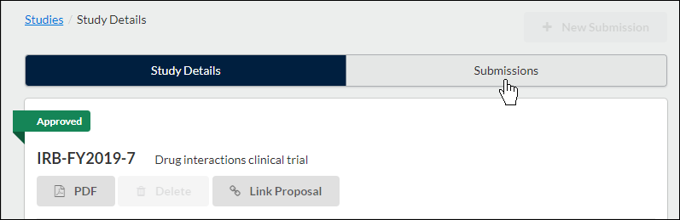

The Submissions tab shows the list of submissions associated with the study, including the submission type, review type and status, decision, and last modified date. Click on the submission you wish to view.
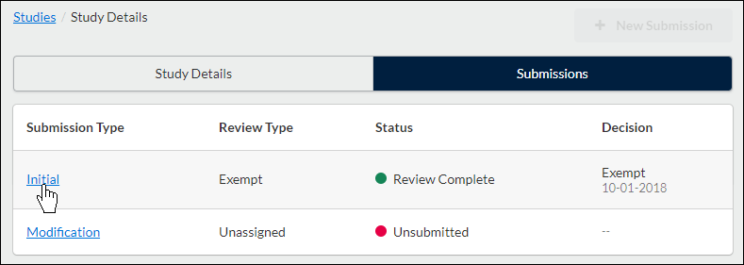

At the bottom of the Submission Details screen, you'll see tabs that vary depending on the submission stage. Tabs may include Approvals, Task History, Letters, Meetings, Decisions, and Linked Proposals.
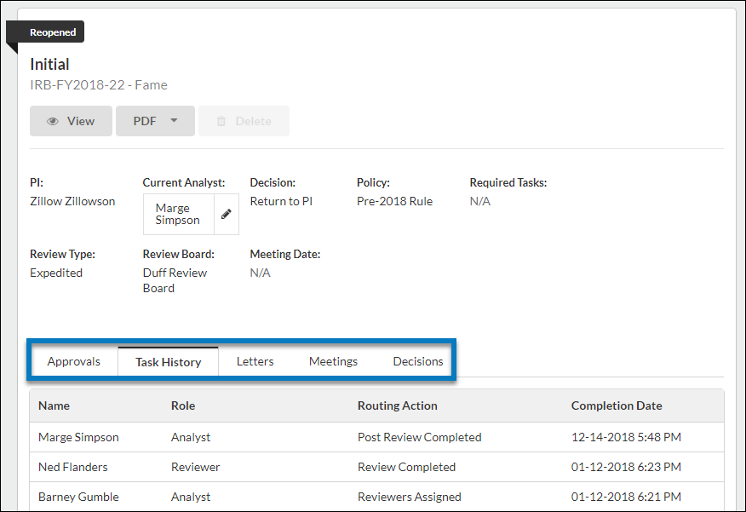

Click on the desired tab to locate the required information.

From Your Dashboard

Click on Submissions in the menu.
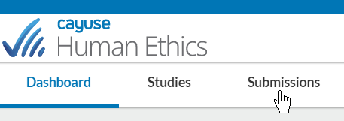

Search for the submission you wish to view, and then click on the submission.
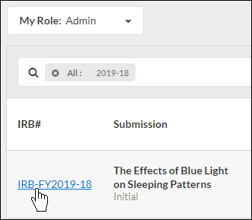
This will bring you to the Submission Details page.

Understanding Submission Types

Available Submission Types

When you first create a study, you also create the initial submission outlining the purpose of that study by clicking on on the Study Details page.

In addition to this initial submission, there are five other types of submissions that you may submit during the course of your research.

Available Submission Types
- Initial: This is the first submission that you create when you enter a new study in the system. The initial submission describes the research you intend to do and the methodology you intend to use. The initial submission must be approved before any research can begin.
- Modification: If you wish to change any of the details of the study after it has been approved, you must submit a modification which must be approved before you can proceed with the changes.
- Renewal: When a study is nearing its expiration date, you must submit a renewal request in order to continue with the research. The renewal will need to be approved before you can continue with the study.
- Incident: You must submit an incident report to inform the Compliance Office of any adverse incidents, as required by your institution. Incident reports may be submitted at any time after a study has been approved, including after it has been closed. More than one incident report may be created for a given study, as needed.
- Withdrawal: A withdrawal submission notifies the Compliance Office that you no longer wish to submit your initial submission and want to withdraw the study. Withdrawn studies are marked as finalized and can no longer be modified. You may create a withdrawal submission at any point once an initial submission has been created, until it has been approved. If the initial submission has been approved, you must create a closure submission in order to close the study if you no longer wish to conduct the research.
- Closure: A closure submission indicates that the research is complete and will not be continuing. Closed studies are marked as finalized and can no longer be modified.
- Legacy: Used for studies imported from previous systems. The legacy submission replaces the initial submission for imported studies. Once the legacy submission is finalized, you can create additional submissions such as modifications, renewals, etc. An Analyst must create and publish a legacy template before users can create legacy submissions or work with studies that have been imported from other systems.

Creating a Modification Submission

- From your Researcher Dashboard, click on Studies.

- Search for the study for which you wish to create a modification, and click on the study number. Please note: Study must be approved.
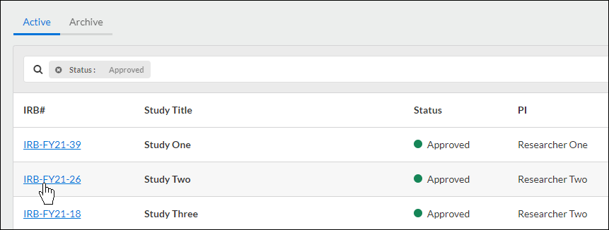

- In the top right-hand corner of the Study Details page, click on the New Submission drop-down menu, and click Modification.
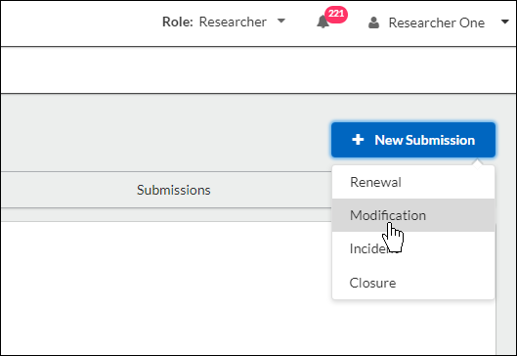

Submission information will populate beneath the Submission Details tab. The person who creates the study is added as the Primary Contact by default, but this can be changed when editing the submission.

Click Edit to begin your submission.
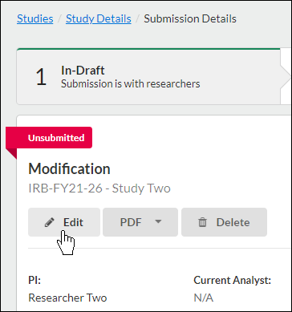

Filling Out Your Submission
Filling out your Modification is a lot like filling out your Inital Submission with some key differences:

- Some sections may be modification specific, and are meant to show reviewers what changes have been made within the other sections.
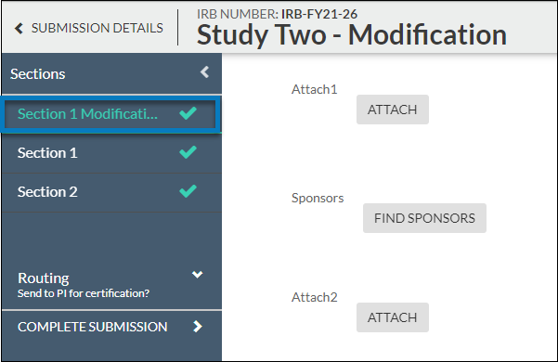

- The other sections are from the approved Initial Submission, and where the modifications are made. Since a Modification is a request for changes, changes do not go into affect until a Modification has been approved.
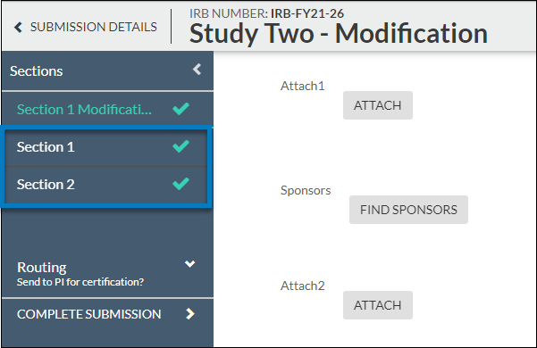

When you're finished, click Complete Submission.

Creating a Renewal Submission

If you have an approved study and need to create a Renewal Submission, you can do so from the Study Details page.

- From your Researcher Dashboard, click on Studies.
- Search for the study for which you wish to create a Renewal Submission, and click on the study number. Please note: Study must be approved.

- In the top right-hand corner of the Study Details page, click on the New Submission drop-down menu, and click Renewal.
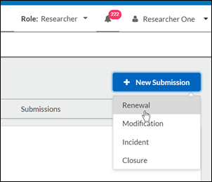
Submission information will populate beneath the Submission Details tab. The person who creates the study is added as the Primary Contact by default, but this can be changed when editing the submission.

Click to begin your submission.

Fill out your submission form, and when you're finished, click Complete Submission to begin the routing process.

Closing a Study

If you need to close your study, you can do so by completing a Study Closure submission.
- On the Study Details page of your study, click on New Submission in the top right-hand corner. In the drop-down menu, click Closure.
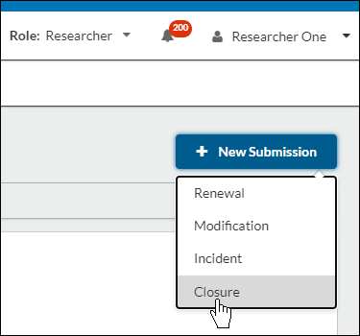
- On the new Submission Details page, click Edit.
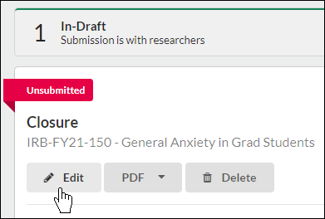
- Fill out the submission form, including all required fields, and click Complete Submission.
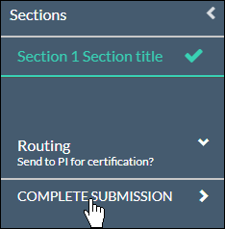

- Certify your closure submission on the submission details page.
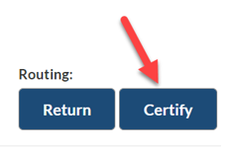
The IRB will need to approve the closure before your study will be marked as closed.

Deleting a Study or Submission

Deleting a Study

You can only delete a study if it has no submissions attached. To delete a study, click on Delete on the Study Details page.
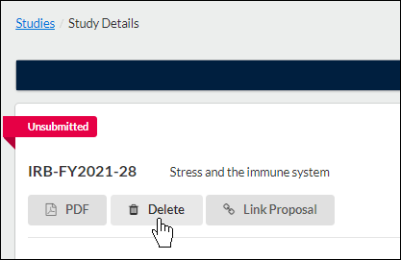
On the confirmation page, click Delete.

Deleting a Submission
You can only delete a submission prior to the initial completion (when Complete Submission is clicked). If a submission can't be deleted, it can be withdrawn instead.
To delete a submission, click on Delete on the Submission Details page.
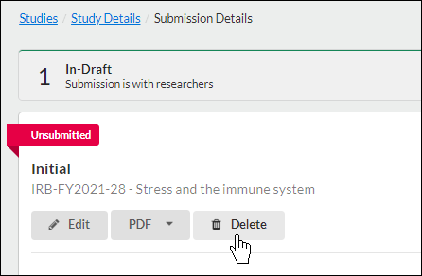

On the confirmation page, click Delete.
