OFFICE OF RESEARCH AND  SPONSORED PROGRAMS  Division of Research Compliance |  |  | Institutional Animal Care and Use Committee  Standard Operating Procedures
Title: Animal Use Protocol Submissions
Effective Date: |  |  | Document Number: |  | IACUC-SOP-003.01
Approval/Date:

__________________________________________ ___________________
Chad W. Hargrave Date
Associate Provost, Chief Research Officer

REVISION HISTORY

PURPOSE
It is the responsibility of the SHSU IACUC to assure that all animal use activity meets federal regulations, policies, and recommendations. The SHSU IACUC must therefore review and approve all proposals for animal use and provide guiding documents for documentation and evaluation of each Animal Use Protocol (AUP) submission.

SCOPE
This SOP will delineate the responsibilities of the Principal Investigator (PI) to timely submit (see IACUC-SOP-012.01 AUP Approval Methods) all proposals and modifications accurately and concisely, to a level that should be understandable to a non-scientist and to describe and give good justification for the aims and design of their study and the use of animals.

DEFINITIONS AND ABBREVIATIONS
SHSU- Sam Houston State University
IACUC- Institutional Animal Care and Use Committee
SOP(s)- Standard Operating Procedure(s)
AUP- Animal Use Protocol
PI- Principal Investigator
Co-PI- Collaborating Principal Investigator
AWIC -The Animal Welfare Information Center
USDA Categories- United States Department of Agriculture Pain Scale Classification of Procedures
NPGC- Non-pharmaceutical Grade Compounds
PO- Oral Route of Drug Administration
IM- Intramuscular Route of Drug Administration
IV- Intravenous Route of Drug Administration
IO- Intraosseous Route of Drug Administration
SQ- Subcutaneous Route of Drug Administration

PROCEDURE
- To log into the Cayuse Platform, click the following link: (https://shsu.app.cayuse.com/)
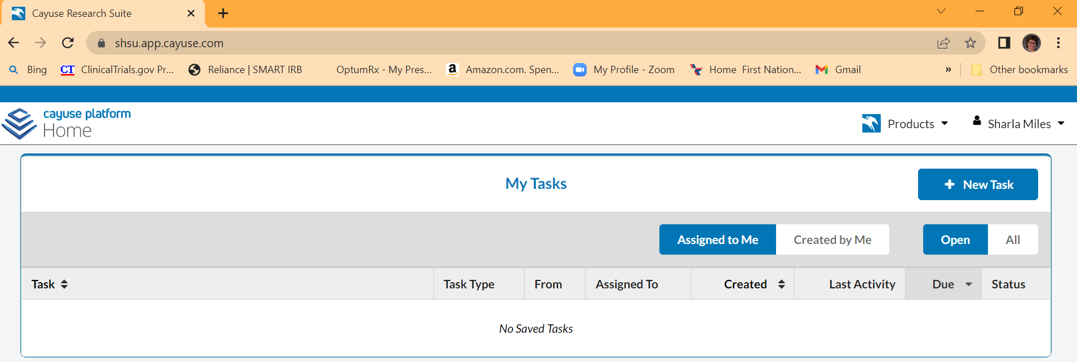
- Click on the Products drop-down arrow to select Animal Oversight:
[NEED SCREENSHOT]
- The AUP is broken into sections and must be filled out in its entirety, electronically, and by the PI.
- PIs are required to complete a Departmental Approval Form for garnering the Department Chair’s approval before submitting your study to the IACUC for review.
  - Options—after creating your protocol, according to the Starting Your Protocol training resource, you will be directed to an Options page, which is the first section in the protocol’s Table of Contents.
  - Protocol Species Grid—the Options section must be updated to include all species associated with the protocol and selecting all procedures the animal will undergo. After saving the changes made to the Options page, this will determine the sections that will be added to the Table of Contents.
  - Protocol Overview—this section contains four tabs that must be addressed [Note: you may click and drag the bottom right corner of any text area to resize it]
    - Title—this tab should contain an appropriate project title for the overall study [Note: for congruency purposes, this title must match any funding proposal associated with this study protocol, if applicable]
    - Lay Abstract—this tab should contain the non-technical lay summary description of the study, avoiding the use of medical or scientific terminology of
      - Overall scientific goals of the proposed work
      - Overall objectives of the proposed work
      - If warranted, the IACUC may ask PIs to include the following in this tab: [note to Committee: this is what UNT IACUC requires; do we want to require this for the lay abstract?]
        - the experiments purpose and need
        - descriptions of animal use
          - explanations of procedures
          - explanations of data collection methods and measures
          - timelines, tables, and charts to explain the study design
          - summarization of the methods that will be used to minimize discomfort, pain, and distress
          - study endpoints and determinations
    - Benefits—this tab should contain
    - Experimental Summary—this tab should contain
  - Funding Information—these sections (note: there is the potential to add federal/foundation, internal, and/or private/other funding) provide funding information to ensure the proposals have designated funding and that any grants and funding award proposals are congruent with what the IACUC is approving. For more information about the congruency procedures, refer to our IACUC-SOP-013.01 Protocol and Grant Congruence Verification SOP.
  - Inside Collaboration
  - Outside Collaboration
  - Protocol Type
  - Species-Specific Sections—the following subsections should include the specifics about the desired animal model(s) [Note: the sections that open for completion will depend on the procedures selected in the Options section]
    - Info—this section allows the PI to include the following information about the species selected for the study
      - Age range of study animals
      - Target weight range
      - Estimate of daily census (e.g., # of cages) [Note: 0 is the default answer currently—this is acceptable for any animals not being housed on campus (e.g., typical for wildlife studies)
      - Estimate of average length of time housed (e.g., # of weeks) [Note: 0 is the default answer currently—this is acceptable for any animals not being housed on campus (e.g., typical for wildlife studies)
      - PIs must indicate whether the animals are Specific Pathogen Free
      - PIs must indicate whether the animals are venomous
    - Choice Justification—PIs must justify the choice of species by indicating why a species lower on the phylogenic scale is not appropriate
    - Source—PIs must indicate if the animals will be purchased through small research animal facility (i.e., the Operations Manager at the Science Annex). If the Science Annex Operations Manager will not be ordering the animals (e.g., the PI has made arrangements with a particular vendor), the PI must select no and identify the source (e.g., Ideal Poultry).
    - Enrichment/Exercise
    - Quarantine/Conditioning
    - Use Locations
    - Strains—this section should include specifics about the desired strain (e.g., strain, age, phenotype (if applicable), and weight)
    - Breeding—only opens when Breeding is selected as a procedure in the Options section
    - Procedures—only opens when Procedures is selected in the Options section
    - Restraint—only opens when Restraint is selected as a procedure in the Options section
    - Surgery—only opens when Surgery is selected as a procedure in the Options section
    - MMS
    - Drugs—only opens when Drugs is selected as a procedure in the Options section
    - Bio-hazard Agents—only opens when Bio-hazard (IBC) is selected as a procedure in the Options section
    - Euthanasia—only opens when Euthanize is selected as a procedure in the Options section
    - USDA Categories—this section provides the number of animals requested and categorizes them as B, C, D, or E based on the USDA pain/distress scale.
      - Justification—any animals being requested in Category E require explanation and justification for needing animals to fall under this category.
        - Classification B: Animals being bred, conditioned, or held for use in teaching, testing, experiments, research, or surgery, but not yet used for such purposes.
        - Classification C: Animals upon which testing, research, experiments, or tests will be conducted involving no pain, distress, or use of pain-relieving drugs.
        - Classification D: Animals upon which experiments, teaching, research, tumor- bearing experiments, surgery, or tests will be conducted which have the potential to cause pain or distress to the animals and for which appropriate anesthetic, analgesic, or tranquilizing drugs will be used to prevent this pain and distress.
        - Classification E: Animals upon which teaching, experiments, research, surgery, or tests will be conducted involving accompanying pain or distress to the animals and for which the use of appropriate anesthetic, analgesic, or tranquilizing drugs will adversely affect the procedures, results, or interpretation of the teaching, research, experiments, surgery, or tests.
    - Methodology
    - Unrelieved Pain/Distress
    - 3Rs
    - Adverse Consequences
    - SOP Exemptions
  - Personnel—this section identifies those participating in study activities through the following three tabs:
    - Personnel Info—this is typically auto-populated from Cayuse Animal Oversight’s Contact Management database. The only action item the PI will need to complete is selecting the checkboxes:
      - Primary Contact
      - Copy Primary Contact on all emails
    - Personnel Activities—this tab will allow the PI to indicate whether research personnel will be handling animals and the procedures
    - Training Profile—this is typically auto-populated from Cayuse Animal Oversight’s Contact Management database
  - Databases Searched—this section is used in order to prevent unnecessary duplication of research and to demonstrate that there are no alternatives addressing replacement, reduction, and/ or refinement to the proposed use of live animals. This procedures is not required for Teaching, Demonstration, or Breeding protocols.
    - Databases Searched—two sources are required to be listed
      - The Animal Welfare Information Center (AWIC) is a great source for alternative options such as computer models, tissue culture, etc. Information on this IACUC-recommended resource can be found under Resources on the SHSU IACUC website.
      - Medline or PubMed is a good source to search and rule out duplication of research.
    - Keywords used in search
    - List any consultation with colleagues, including names and qualifications as a basis for why they were consulted
    - Journals used in the search, if applicable
    - List any relevant scientific meetings attended, if applicable
    - Results of the search
      - An open text field will allow you to describe any potential alternatives to painful procedures and to state why these alternatives are not appropriate for the study.
      - More detailed documentation and justification will be required for Category D or E proposals and should fully explain considerations of alternatives and the determination that none are available.
    - Date range covered in search
      - Should not be more than 90 days prior to submission of application [Note to Committee: this is what UNT requires; what do we want to require?]
    - Number of years covered in search
  - Endpoints—this section will
  - Submit Protocol—before submitting the protocol, follow the specific instructions contained in this section.
    - Assurances—by submitting the protocol, the PI is acknowledging and assuring that the protocol is following PHS Policy and Animal Welfare Act requirements as described in SHSU Animal Welfare Assurance.
  - Attachments—this section should contain all documentation that is relevant to the project, including but not limited to CITI training, copies of collection permits, and the previously mentioned departmental approval form.
  - Cancel Draft Protocol—this section will allow the PI to cancel the draft for any reason.
  - Preview Protocol—this section will allow the PI to not only preview the completed protocol but to print out a pdf copy of the protocol.
REFERENCES

APPENDICES

